**Task**

**Implement a basic Node.js Express server that performs CRUD operations on a list of products.**

1. **Read all products: Implement a GET request to retrieve all products.**

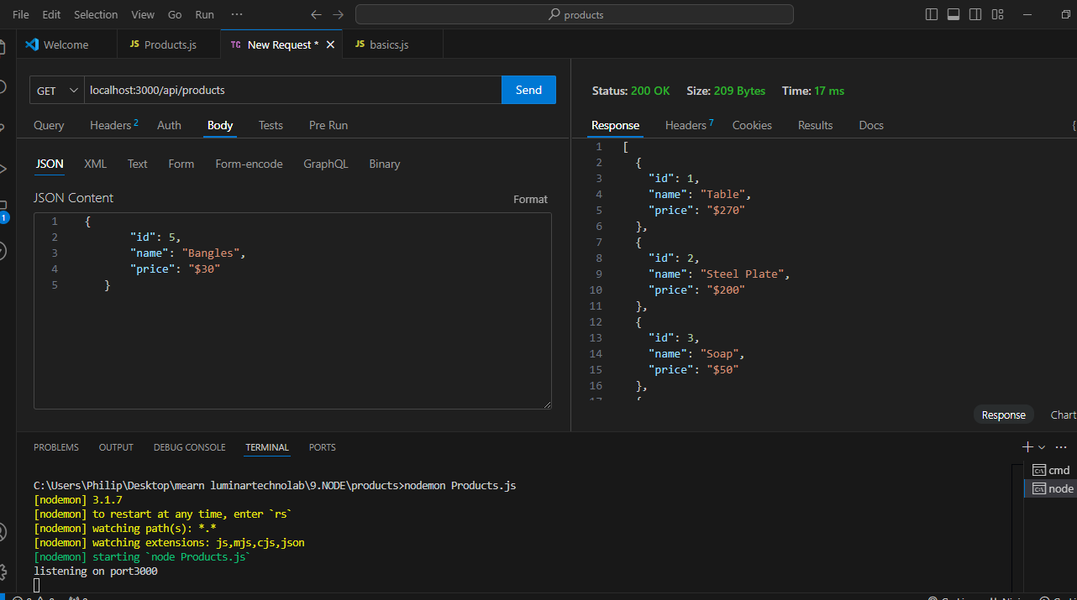

**Code:**

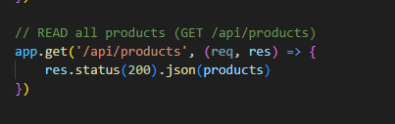

1. **Create a product: Implement a POST request to add a new product with fields like id, name, and price**.

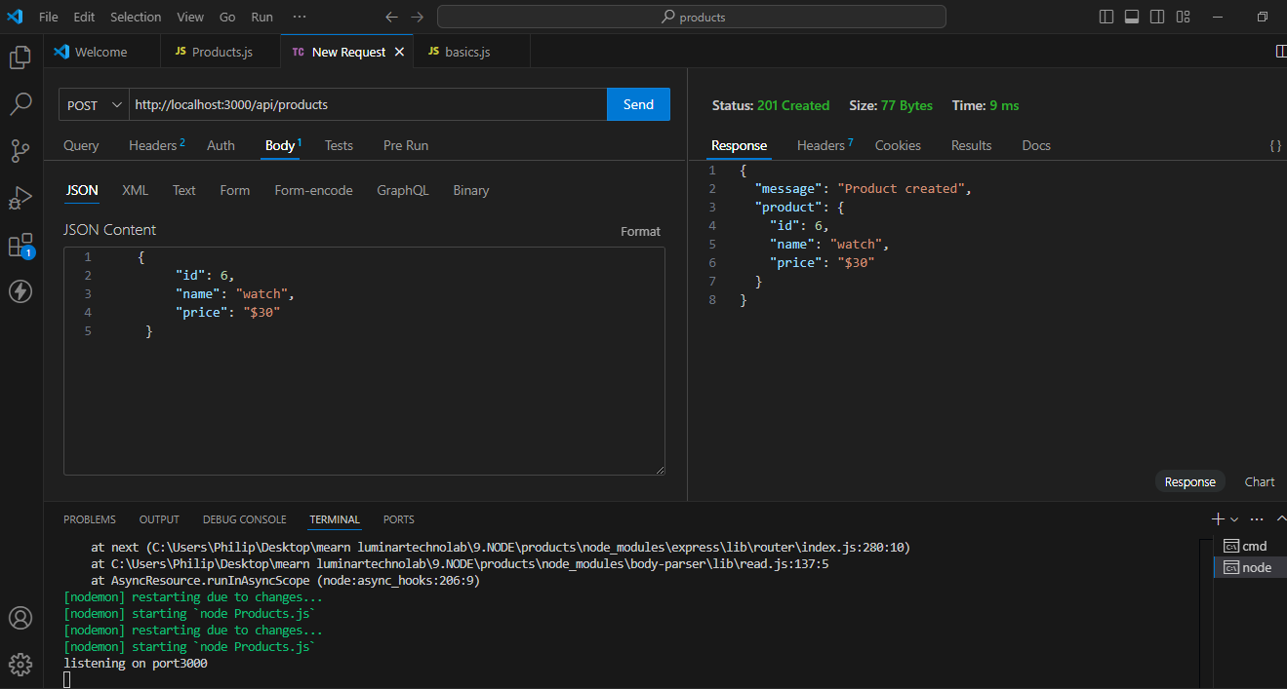

**Code:**

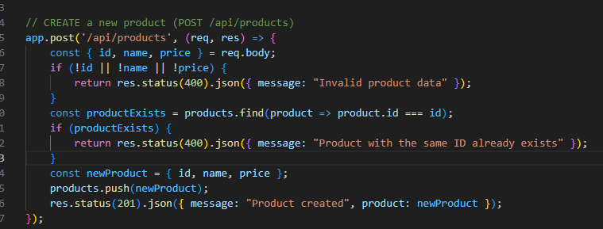

1. **Read a single product: Implement a GET request to fetch a product by its** **ID.**

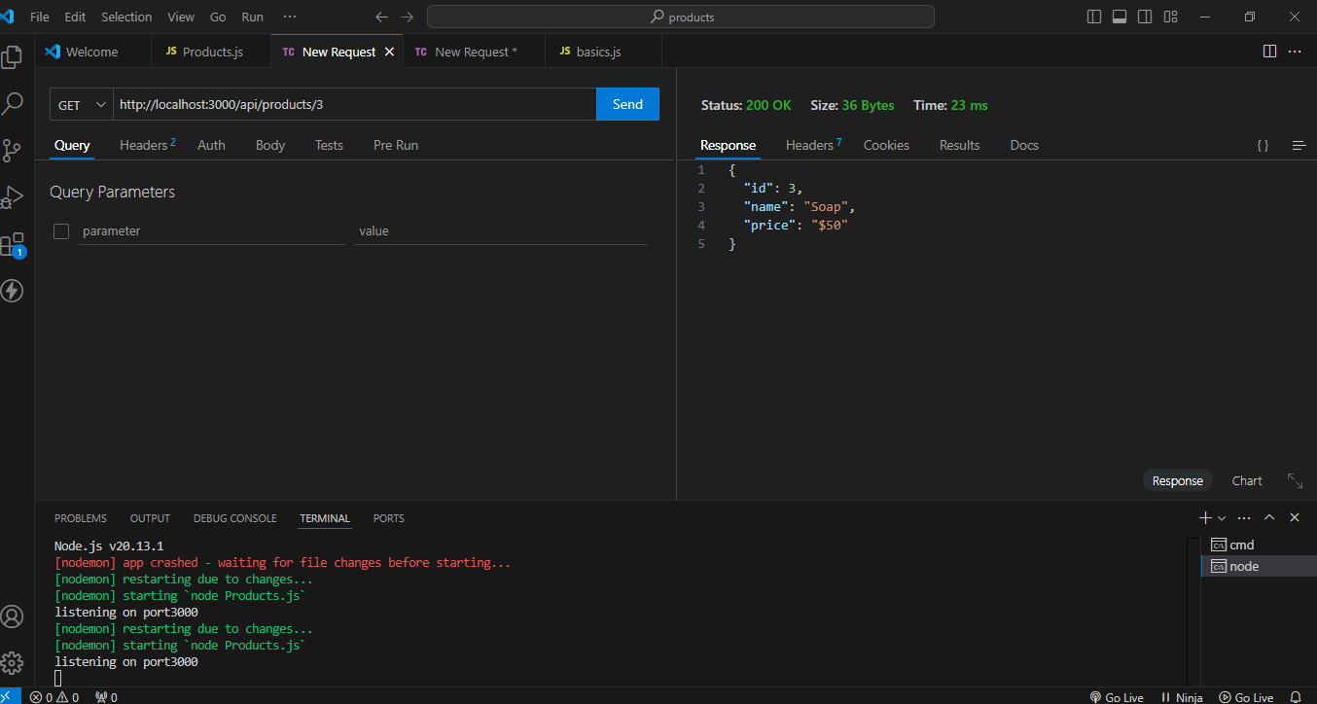

**Code:**

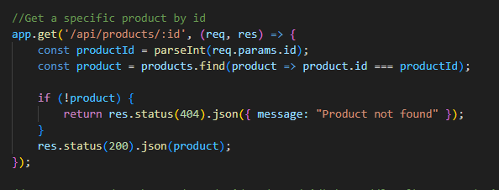

1. **Update a product: Implement a PUT request to update the name and price of a product by its ID.**

**Before Update:**

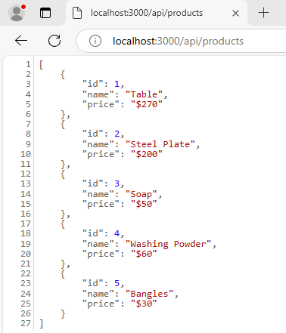

**After Update:**

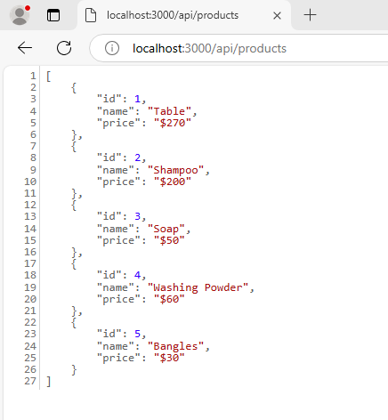

**Code:**

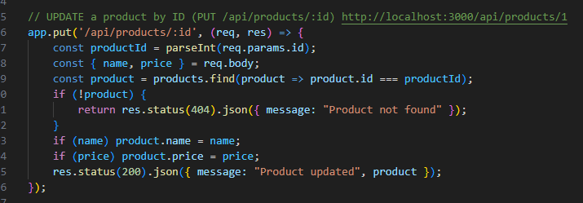

1. **Delete a product: Implement a DELETE request to remove a product by its ID.**

**Before Delete:**



**After Delete**

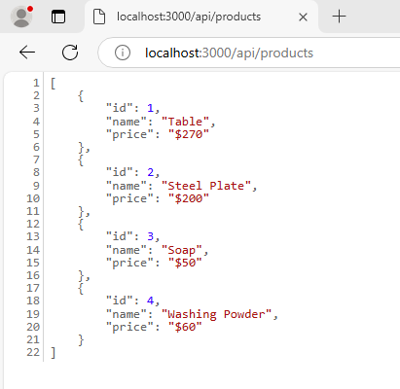

**Code:**

